Using PURPLE PEN to create an orienteering course from a jpg map.

Based on version 2.6.2 by Peter Golde (available for free from www.purplepen.golde.org/)

Run the downloaded file to install it (on older computers it may need to install the ‘Microsoft .NET Framework’ as well.)

It should be noted that the PP built-in help has improved - but here is my version.

Obtain a map file, as a jpg at 600 dpi (dots per inch). For an A4 map this should be in the order of 1.5MB.

Start Purple Pen and select ‘Create a new event...’ then add an event title.
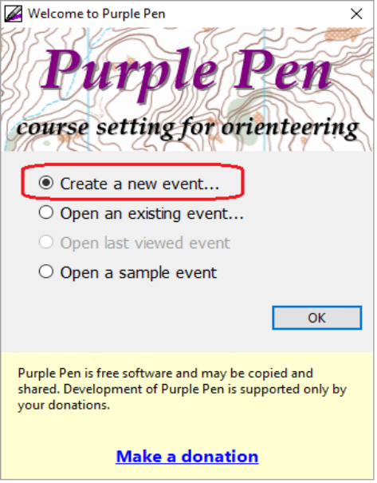
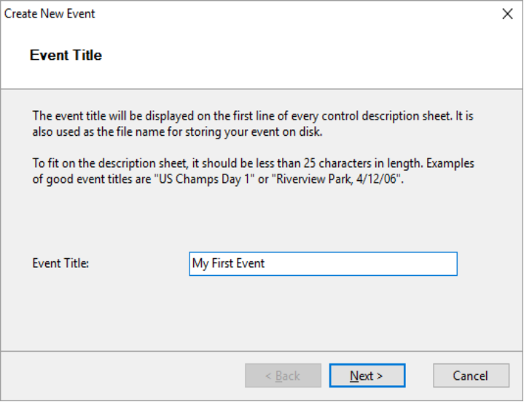

Choose the map file. Select file type ‘Image files’ at bottom of window to see jpg files.
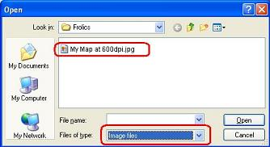

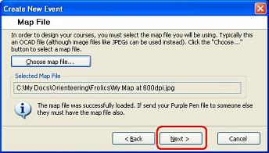

Select image resolution of 600 and enter correct map scale (usually 10000). The print scale should be the same.
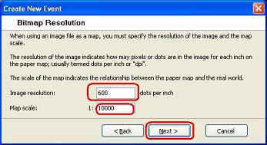
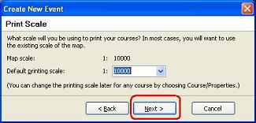

Select the paper size (usually A4) and portrait or landscape.
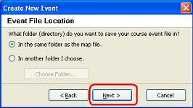
Decide where you want to save the Purple Pen file.

Choose a number for the first control. (DFOK hold 60 to 100) then click ‘Finish’.

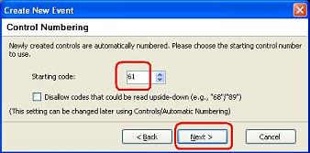
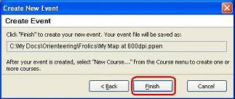

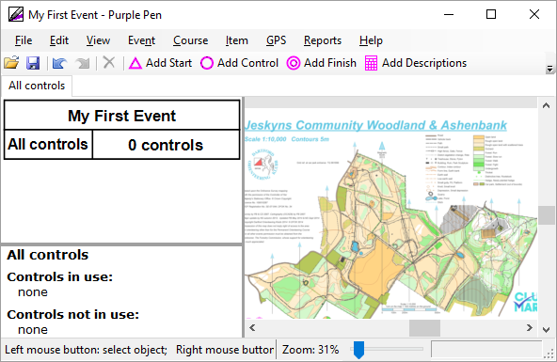
Your map should open.

The map will look pale. If you want it to be brighter use View, Map Intensity to set High or Full.

It is important to check that the map will print correctly before you continue.

Create a course. Use Course, Add Course and give it a name.

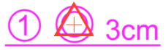
All new maps should have this arrangement on the map:
Find this first.

Click ‘Add Start’ button and place start onto the symbol – it should fit exactly. If not, then you have set the map scale or resolution incorrectly – this MUST be corrected before you continue. Check that the map is actually 600 dpi (ask the mapping officer) and check the values entered when you started Purple Pen.
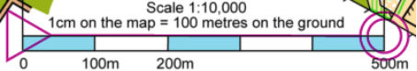
Move the Start to the start of the map scale and add a
Finish at the end.
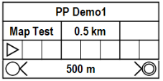

The Control Descriptions for the course (NOT All Controls) should show the same distance
as the scale, if not, this MUST be corrected before you continue.

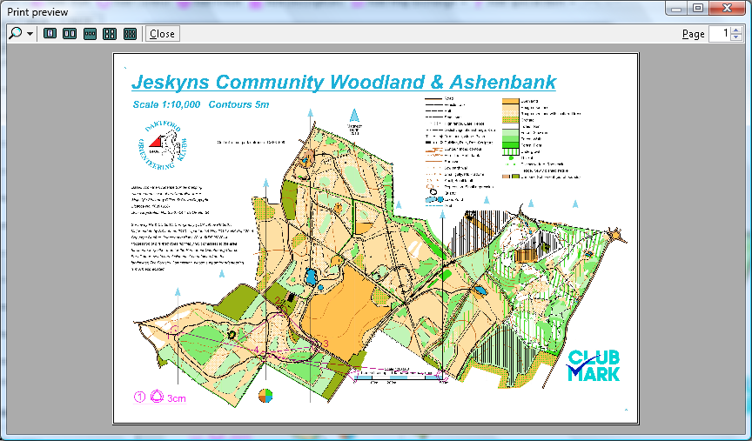

Check the print preview: Use File, Print Courses, Preview.
The full map should fill the page, if not, this MUST be
corrected before you continue.

The next step is to create each of your courses. Use Course, Add Course and give it a name. Choose Normal or Score event. Don't be tempted to start drawing a course until you have done this.
Each course will have a ‘tab’ at the top.
Select your first course tab. NOTE Avoid using the All Controls tab when setting a course.
Zoom the map by using the mouse wheel (or View, Zoom or slider at bottom of window)
To move the map, use right mouse and drag (or use scroll bars)

Move the Start and Finish to the correct locations on the map.

Click ‘Add Control’ button, choose location on map and click mouse. Repeat!
A list of controls is created on left of screen as you proceed.

When adding controls to a second course, the existing controls on other courses will appear and ‘snap’ will operate.

If you make a mistake or want to move a control just click (it will turn red) and drag it to the new place.

To add a control between existing controls click the lower number (it will turn red)
Click ‘Add Control’ button, choose location on map and click mouse.
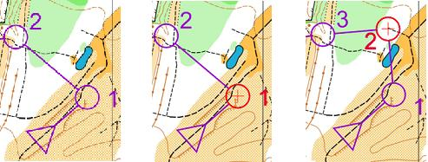

WARNING: If you tweak a
control position it will change
the position of that control on
all courses that use it.

If you use F4 all controls used on all courses will be shown on your map to help you select a control.

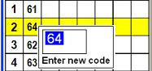
The new control is added but note that its number will be out of sequence.
This can be changed, if you wish, by clicking the control number in the
description list or using Automatic Renumbering.

To zoom the view to the entire map use F3, for the course only use F2
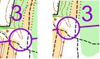
The control numbers on the map can be moved by dragging to allow better readability.
They do inter-react a little so check them all before you finish.
The control numbers can be adjusted separately on each course.

Cutting circles
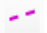
Click the circle (it will turn red)
Click the ‘Add Gap’ icon (or use Ctrl G)
Click at the point you want the gap to be. A fixed gap is entered, drag the blue handles for a bigger gap.
Use the Item menu to delete the gap.

Cutting lines
Click the line (it will turn red)
Click the ‘Add Gap’ icon (or use Ctrl G)
Drag the blue dots across the portion you wish to erase.
You can even cut the line across a bend.
Use the Item menu to delete the gap.

Bending lines
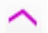
Click the line (it will turn red)
Click the ‘Add Bend’ icon (or use Ctrl B)
Click the line to get a blue square.
Drag the blue square to move the line. Repeat the process to add another bend.
Use the Item menu to delete the bend.

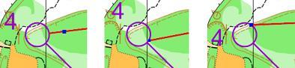
Moving where line touches circle.
Click the line (it will turn red)
Click the ‘Add Bend’ icon (or use Ctrl B)
Click the line near the circle to get a blue square.
Drag the square to another point on the circle

Control Descriptions
Most items in the list of control descriptions can be altered by clicking the relevant box.
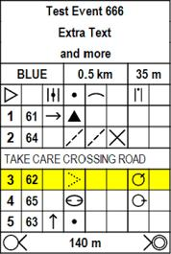
The event name may be changed or extended to more rows.
The course name may be changed and the climb in metres.
Control codes may be changed and symbols added.

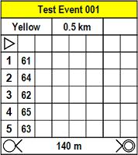
Extra text lines may be added (e.g. TAKE CARE
CROSSING ROAD) by clicking a control description
then selecting ‘Item’, ‘Add text line’ then choosing
‘Above’ or ‘Below’ current line.
The text may be more than one line.

Adding descriptions to map
Click ‘Add Descriptions’ button then drag an area on the map.
Descriptions can be one or more columns by dragging when adding to the map.
If you add descriptions again the original copy will be deleted.
To change the format (Symbols, Text or Both), use ‘Course’, ‘Properties’

Special Items - White Out Area
This allows you to hide parts of the map file and can be useful behind the descriptions or if part of the map is not used. Note that other items can be added on top of the white out but to alter them the white out area must be moved first. Text boxes can be stretched (without changing text size) so 'handles' are outside white out area but you must be able to click on the actual text to select it.

Special Items - Image
This allows you to add a logo or other image to the map.

Special Items - OOB
Select ‘Add Special Item’ then ‘Out Of Bounds Area’. Click and drag the first line then release mouse button. Each additional point must also be dragged. Double-click to close the area.
The whole area may be dragged as well as each of the nodes.
‘Add Bend’ can be used to add extra points to the area.

Special Item - Forbidden Route
Select ‘Add Special Item’ then ‘Forbidden Route Marking’. Click on map to add a single ‘X’. Repeat to add more.

Special Item - Crossing Point
Select ‘Add Special Item’ then ‘Crossing Point’. Use ‘Item’, ‘Rotate’ if necessary.
Lines between controls will automatically be routed through the crossing points.

To add text to the map.
Select ‘Add Special Item’ then ‘Text’
Enter required text then drag a box on map. The text will expand to fill the box.
Certain special items (e.g. Course Name) can be added here.
To edit text use 'Item', 'Change Text'
Note that the text is a single line only.

Text Size and Colour.
The default colour is purple. This can be changed (globally) by ‘Event’, ‘Customise Course Appearance’. The default is the BOF approved colour. Text size can be changed in the same place.

Displaying items on specific courses.
Any of the special items you add can be displayed on any of the courses. Use 'Item', 'Change Displayed Courses' to select the courses that the text will appear on.

Dots in control circles.
Use 'Event', 'Customize Appearance' then 'Center dot diameter'. Use a value 0.5 to 1.0

Custom Control Descriptions.
Any text description can be customised, for example a Special Item could be changed to a Dinosaur on a White course.
Use 'Event', 'Customize Description Text'. Note that this text will appear on all courses with text descriptions.

Other Considerations:

Automatic Renumbering

Use 'Event', 'Automatic Numbering' to renumber all of the controls you have used.

Running 2 or more instances of Purple Pen
You can, should you so desire, run more than one instance of Purple Pen, perhaps to view a previous course.

Control Circle Colours
If you want two sets of controls in different colours (e.g. to allow for two laps during a KNC score) the maps will need to be overprinted. At the moment the practicalities of this are unknown.
An alternative solution is to print one set of controls on one side of map and another set on the other - this will be more expensive.

Sending for Printing:
You must send:
Map file (whether JPG, OCAD or PDF)
Purple Pen file
It may also be useful to send PDF files of the courses – you will certainly want copies of these for yourself too.

Route Gadget Files:
Use File, Create RouteGadget Files. This will create two files <coursename>.gif and <coursename>.xml

Autodownload File:
Use File, Create Data Interchange File (IOF XML). CHECK IF THIS IS SAME FILE

Control placing/collection maps:
If you are using other people to put out or collect controls you can create a 'course' for each person. This means they know how far they have to go and also get control descriptions.

Limitations:
You have to calculate ‘climb’ yourself and any value you enter is rounded to the nearest 5m.
There is no Copy/Paste support

USEFUL KEYBOARD SHORTCUTS

F1 = Help
F2 = View course
F3 = View map
F4 = View all controls, no matter which course is selected
Ctrl-A = Add control
Ctrl-B = Add bend
Ctrl-G = Add gap
Ctrl-S = Save
Ctrl-Y = Redo
Ctrl-Z = Undo
Esc = Un-select

-oOo-

